**Sagar Institute Of Science and Technology**

Approved by AICTE & affiliated to RGPV Bhopal

**BHOPAL,M.P**

**(2019– 2023)**

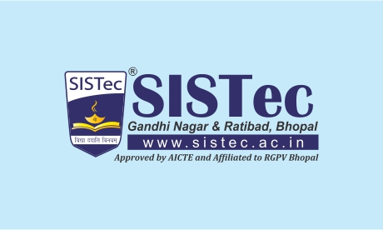

A Report on

“Overview of Internship Process”

**Bachelor of Technology**

**In**

**Computer Science and Engineering**

Submitted by

**Ashutosh Gupta(0187CS191038)**

Internship Carried Out at

**Aartech Solonics Ltd. Mandideep , Bhopal(MP).**

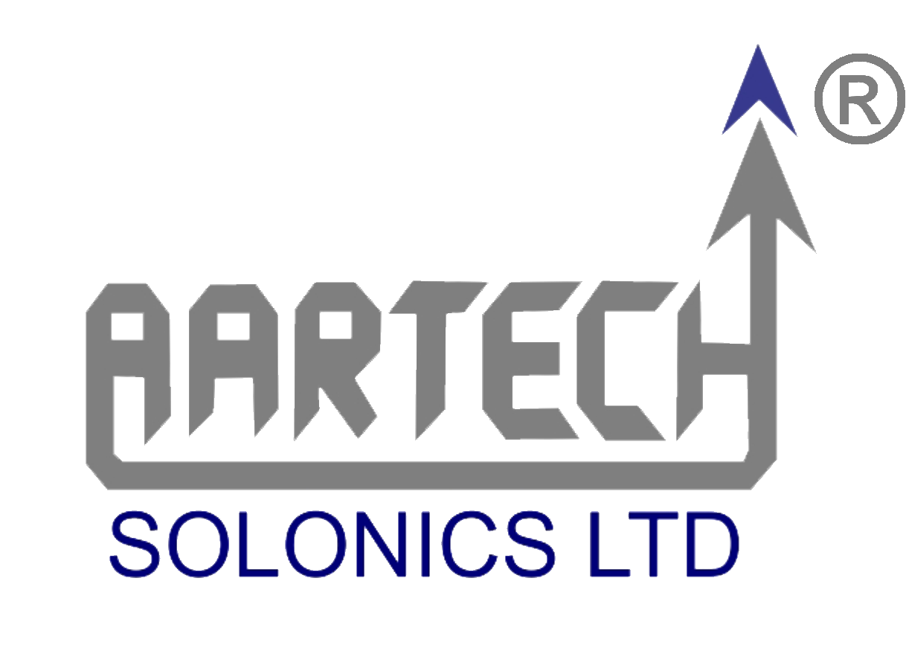

(Duration: 30th April , 2021 to 25th Sep, 2021)

Acknowledgement

The success and final outcome of this internship required a lot of guidance and assistance from many people and I am extremely privileged to have got this all along the completion of my internship. All that I have done is only due to such supervision and assistance and I will not forget to thank them.

I express my respect and gratitude to Mr. Amit Raje sir, Chairman and Director of Aartech Solonics Ltd., Mandideep ,Bhopal, (MP). For providing me an opportunity to do internship training in their Organizations.

I express my deep sense of gratitude to my guide Mr. Himanshu Gupta sir and Mr. Ritesh Dhiman sir , Executive Engineer of IRDD Innovation lab , Aartech solonics Ltd. Mandideep, Bhopal (MP). for his valuable suggestions and for his inspiration, motivating guidance and who has been the driving force behind this work and who have constantly dedicated his precious time with timely suggestions and ideas to successfully carry out the internship work.

Also, I would like to extend my sincere esteems to all the people who worked along with me in Aartech Solonics Ltd with their patience and openness they created an enjoyable working environment.

Last but not the least; I would like to thank my  **Parents and Friends** for their moral support during critical phases of my work.

Ashutosh Gupta

(0187cs191038)

**Objectives**

**The main objectives of the Internship are: -**

• To apply the acquired knowledge and skills in a practical situation.

• To become acquainted with real life problem solving.

• To work in free environment.

• To learn how to plan things out carefully.

• To develop social and communicative skills.

• To carry out a project which is useful for the employer.

##### Table of contents

|  |  |  |
| --- | --- | --- |
| **S. No.** | **Topics** | **Page No.** |
| **1)** | **Introduction** | **5-6** |
| **2)** | **Description of Company Profile** | **7-8** |
| **3)** | **Departments of the Company**   * IRDD Innovation Lab * FaraDigm * QC(Quality and control) * AIC Aartech |  |
| **4)** | **Project Description** |  |
| **5)** | **Tasks Description** |  |
| **6)** | **Conclusion** |  |

**Introduction:-**

This report is a short description of my 100days internship carried out as an Intern at **IRDD INNOVATION Lab**. The internship was carried out within the company Aartech Solonics Ltd in 2021. Since I am interested in Hardware , software, Designing and Research, the work was concentrated on design, Exploration and mainly Research . At the beginning of the internship I formulated several learning goals, which I wanted to achieve: •

to understand the functioning and working on Different Types of Projects in industry

•

to see what is like to work in a professional environment; •

to see if this kind of work is a possibility for my future career;

•

to better use and understand my academic knowledge in a practical environment •

to see what skills and knowledge I still need to work in a professional environment;

•

To learn about the organizing of a manufacturing industry (planning, preparation, permissions etc.) •

to learn about various testing methodologies

to get fieldwork experience as well as office work experience;

•

to enhance my communication skills to build a network.

This internship report contains my activities that have contributed to achieve a number of my stated goals. In the following chapter a description of the organization Aartech Solonics Ltd and their activities is given. After this a reflection on my functioning, and the learning goals achieved during the internship are described. Finally I give a conclusion on the internship experience according to my learning goals.

**Description of Company Profile:-**



Aartech was founded in the year 1985 driven by the entrepreneurial spirit of its founder **Mr. Anil Anant Raje**. Aartech started commercial production on 1st January 1988, celebrated as Aartech’s Foundation Day every year. Aartech was initially incorporated as a private limited company – and subsequently converted into a public limited company in March 1992.

**Location of the Company:-**

Registered Office:

‘Aashirwad” E-2/57, Arera Colony, Bhopal, Madhya Pradesh (M.P.) India 462016

Unit #1-Mandideep:

35-A/36 Sector-B, Industrial Area, Mandideep

Aartech Solonics Ltd is a System Solution Oriented R&D Enterprise in the field of Specialized and Selected Energy Applications. Aartech is mostly known for its rich credentials in the highly specialized field of Fast Bus Transfer Systems for Medium Voltage Installations in Power Plants and Process Industries.

Aartech Solonics Ltd Develops following Products:-

#### [Fast Bus Transfer System](https://aartechsolonics.com/products/bts-2000-fast-bus-transfer-systems/)

BTS 2000 Fast Bus Transfer System is an advanced microprocessor based Bus Transfer System for Power Generation Utilities & Continuous Process Industries.

#### [Control Relay panel](https://aartechsolonics.com/products/control-relay-panels/)

A control & relay panel is designed to provide to control the associated line or transformer through outdoor switchgear at various 11KV and 33KV zonal substations.

#### [KranKing Ultracapacitors](https://aartechsolonics.com/products/faradigm-ultracapacitors/)

FaraDigmTM is a range of Ultracapacitors for power quality applications. The Ultracapacitors operate at different voltages, and for a particular operating voltage, there are Ultracapacitors

#### [WTC](https://aartechsolonics.com/products/new-products/wtc-machine/)

WTC is a fully automatic composting machine, which converts all kinds of organic waste into compost within 24 hours in your own building/premises and solves your waste management problems completely.

#### [WTD](https://aartechsolonics.com/products/wedge-tightness-detector/)

Stator wedges are traditionally tested for tightness by tapping them with a hammer and listening to the sound produced. Electronic wedge tightness evaluation is faster, more accurate and provides more consistent results.

#### [BestCase](https://www.bestcase.in/)

BestCase – Largest Range of Professional Looking, Rugged, Affordable, Quality Cases and Enclosures in India, available Ex-Stock along with customized durable foams of all types as per your application requirements

**Department of Company:-**

**IRDD Innovation Lab:-**

IRDD stands for **Industrial Research Design and Development.**  I have performed my internship Program in IRDD Department. Here mainly focus on Designing and Developing . They Developed different - different kind of Electronic Projects as par the Customer requirement. Being a part of this department, I have Developed a Product which is known as Rapid Test Kit(Full Details is given on Page no. ).

**Project Description:-**

CAN 2 MODBUS Converter(with appropriate calculations). For more details Please refer SRS.